Sample Video 1: Drink/CastAway2_drink_u_cm_np1_le_goo_8

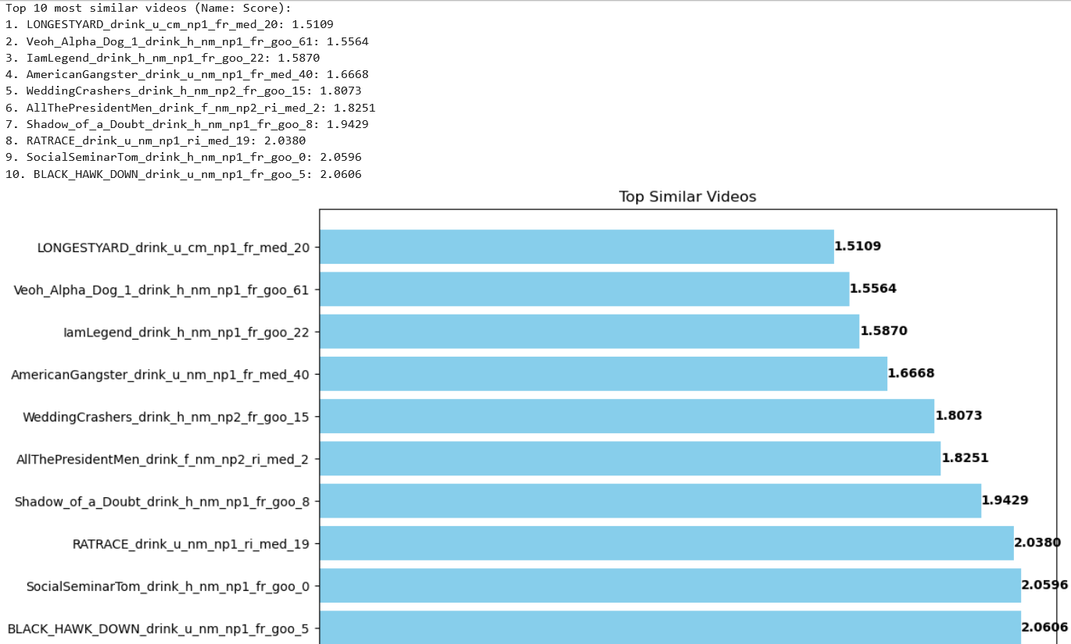

1. LONGESTYARD_drink_u_cm_np1_fr_med_20: 1.5109

2. Veoh_Alpha_Dog_1_drink_h_nm_np1_fr_goo_61: 1.5564

3. IamLegend_drink_h_nm_np1_fr_goo_22: 1.5870

4. AmericanGangster_drink_u_nm_np1_fr_med_40: 1.6668

5. WeddingCrashers_drink_h_nm_np2_fr_goo_15: 1.8073

6. AllThePresidentMen_drink_f_nm_np2_ri_med_2: 1.8251

7. Shadow_of_a_Doubt_drink_h_nm_np1_fr_goo_8: 1.9429

8. RATRACE_drink_u_nm_np1_ri_med_19: 2.0380

9. SocialSeminarTom_drink_h_nm_np1_fr_goo_0: 2.0596

10. BLACK_HAWK_DOWN_drink_u_nm_np1_fr_goo_5: 2.0606

Sample video 2: Cartwheel/Bodenturnen_2004_cartwheel_f_cm_np1_le_med_0.avi

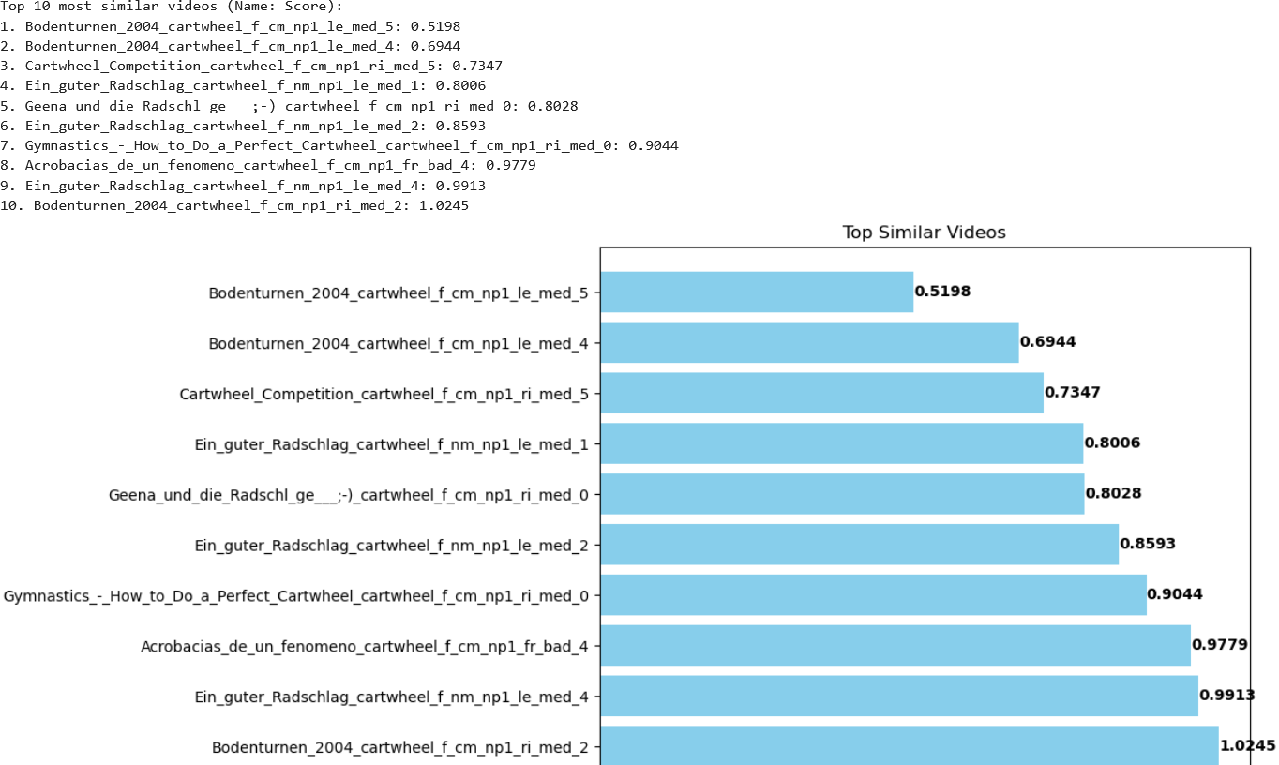

1. Bodenturnen_2004_cartwheel_f_cm_np1_le_med_5: 0.5198

2. Bodenturnen_2004_cartwheel_f_cm_np1_le_med_4: 0.6944

3. Cartwheel_Competition_cartwheel_f_cm_np1_ri_med_5: 0.7347

4. Ein_guter_Radschlag_cartwheel_f_nm_np1_le_med_1: 0.8006

5. Geena_und_die_Radschl_ge___;-)_cartwheel_f_cm_np1_ri_med_0: 0.8028

6. Ein_guter_Radschlag_cartwheel_f_nm_np1_le_med_2: 0.8593

7. Gymnastics_-_How_to_Do_a_Perfect_Cartwheel_cartwheel_f_cm_np1_ri_med_0: 0.9044

8. Acrobacias_de_un_fenomeno_cartwheel_f_cm_np1_fr_bad_4: 0.9779

9. Ein_guter_Radschlag_cartwheel_f_nm_np1_le_med_4: 0.9913

10. Bodenturnen_2004_cartwheel_f_cm_np1_ri_med_2: 1.0245

Sample Video 3: sword_exercise/Blade_Of_Fury_-_Scene_1_sword_exercise_f_cm_np1_ri_med_3.avi

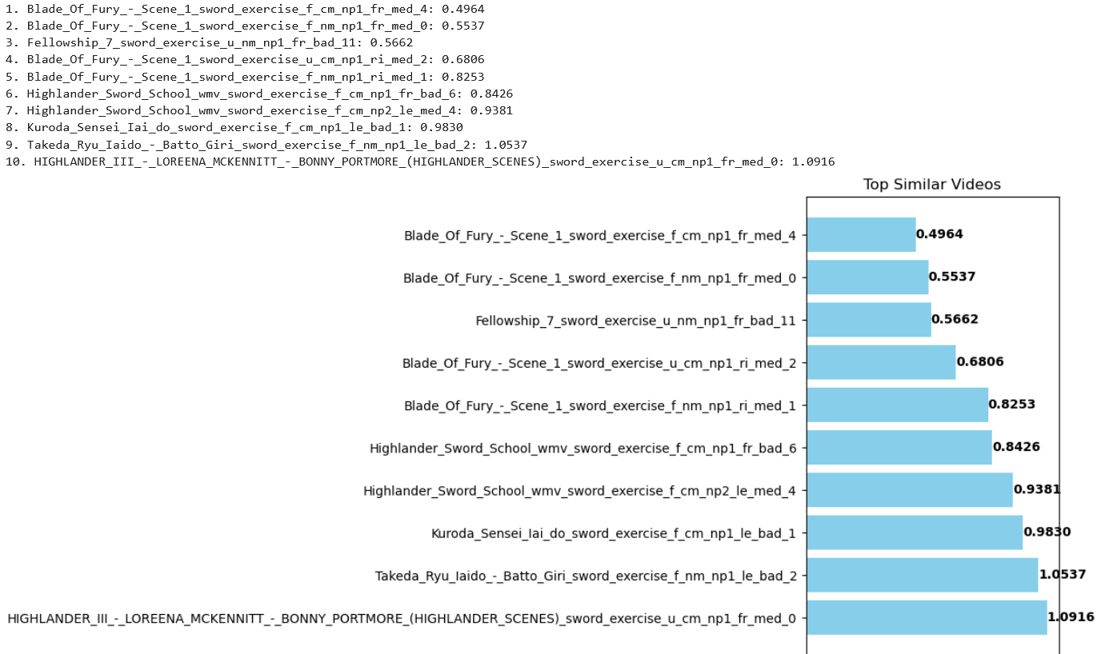

1. Blade_Of_Fury_-_Scene_1_sword_exercise_f_cm_np1_fr_med_4: 0.4964

2. Blade_Of_Fury_-_Scene_1_sword_exercise_f_nm_np1_fr_med_0: 0.5537

3. Fellowship_7_sword_exercise_u_nm_np1_fr_bad_11: 0.5662

4. Blade_Of_Fury_-_Scene_1_sword_exercise_u_cm_np1_ri_med_2: 0.6806

5. Blade_Of_Fury_-_Scene_1_sword_exercise_f_nm_np1_ri_med_1: 0.8253

6. Highlander_Sword_School_wmv_sword_exercise_f_cm_np1_fr_bad_6: 0.8426

7. Highlander_Sword_School_wmv_sword_exercise_f_cm_np2_le_med_4: 0.9381

8. Kuroda_Sensei_Iai_do_sword_exercise_f_cm_np1_le_bad_1: 0.9830

9. Takeda_Ryu_Iaido_-_Batto_Giri_sword_exercise_f_nm_np1_le_bad_2: 1.0537

10. HIGHLANDER_III_-_LOREENA_MCKENNITT_-_BONNY_PORTMORE_(HIGHLANDER_SCENES)_sword_exercise_u_cm_np1_fr_med_0: 1.0916

Sample Video 4: sword/AHF_longsword_against_Rapier_and_Dagger_Fight_sword_f_cm_np2_ri_bad_0.avi

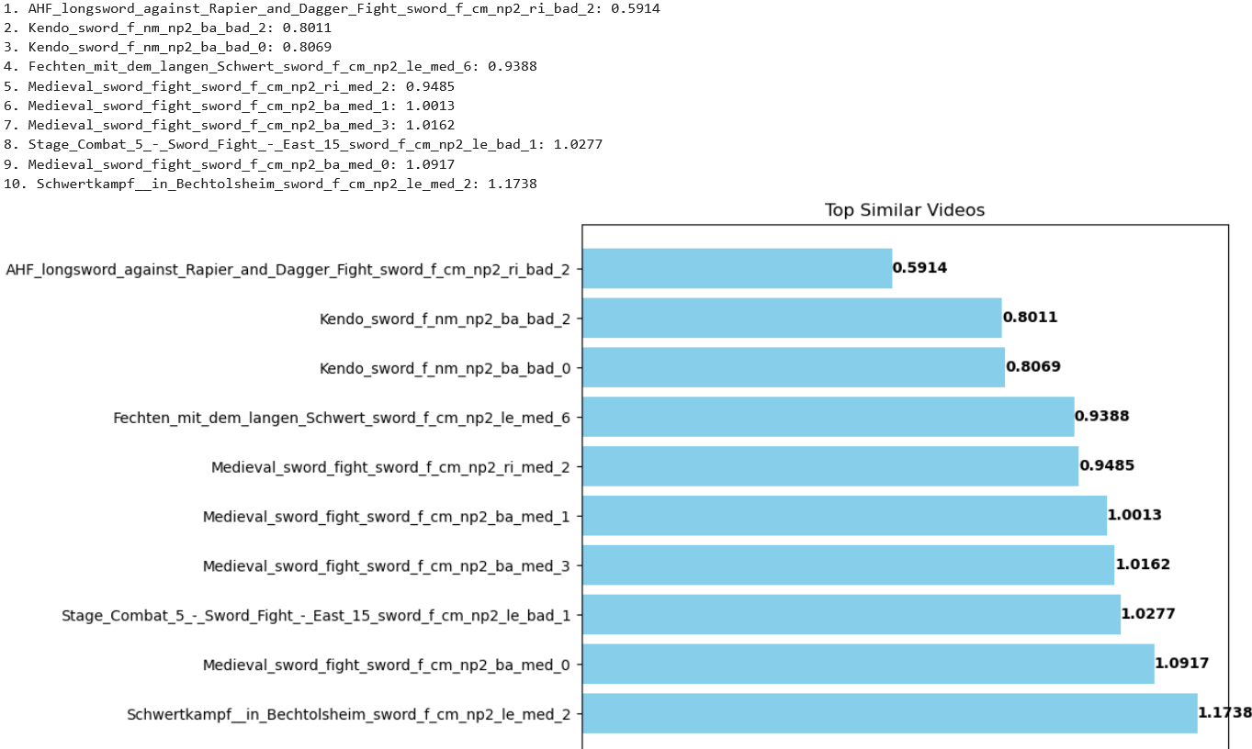

1. AHF_longsword_against_Rapier_and_Dagger_Fight_sword_f_cm_np2_ri_bad_2: 0.5914

2. Kendo_sword_f_nm_np2_ba_bad_2: 0.8011

3. Kendo_sword_f_nm_np2_ba_bad_0: 0.8069

4. Fechten_mit_dem_langen_Schwert_sword_f_cm_np2_le_med_6: 0.9388

5. Medieval_sword_fight_sword_f_cm_np2_ri_med_2: 0.9485

6. Medieval_sword_fight_sword_f_cm_np2_ba_med_1: 1.0013

7. Medieval_sword_fight_sword_f_cm_np2_ba_med_3: 1.0162

8. Stage_Combat_5_-_Sword_Fight_-_East_15_sword_f_cm_np2_le_bad_1: 1.0277

9. Medieval_sword_fight_sword_f_cm_np2_ba_med_0: 1.0917

10. Schwertkampf__in_Bechtolsheim_sword_f_cm_np2_le_med_2: 1.1738